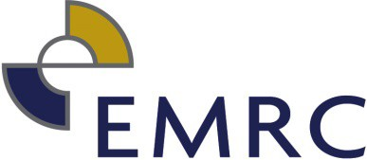
REGISTER OF GIFTS AND CONTRIBUTIONS TO TRAVEL FROM 1 JULY 2020 – 30 JUNE 2021

GIFTS

NAME OF RELEVANT PERSON MAKING DISCLOSURE |  | DESCRIPTION OF GIFT | NAME OF PERSON WHO MADE GIFT | ADDRESS OF PERSON WHO MADE GIFT | DATE GIFT WAS RECEIVED | ESTIMATED VALUE OF GIFT AT TIME MADE | NATURE OF RELATIONSHIP BETWEEN RELEVANT PERSON AND PERSON WHO MADE GIFT
Angela Wolstencroft | Lunch |  | Dr Jude Balm | Infinity Training | 14/12/2020 | $60 | Supplier

Relevant Persons no longer serving or employed at the EMRC

CONTRIBUTIONS TO TRAVEL

NAME OF RELEVANT PERSON MAKING DISCLOSURE | DESCRIPTION OF CONTRIBUTION | NAME OF PERSON WHO MADE CONTRIBUTION | ADDRESS OF PERSON WHO MADE CONTRIBUTION | DATE CONTRIBUTION WAS RECEIVED | ESTIMATED VALUE OF CONTRIBUTION AT TIME IT WAS MADE | NATURE OF RELATIONSHIP BETWEEN RELEVANT PERSON AND PERSON WHO MADE CONTRIBUTION | DESCRIPTION OF TRAVEL | DATE OF TRAVEL
 |  |  |  |  | $
 |  |  |  |  | $

