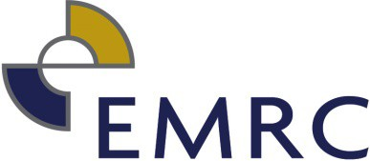
REGISTER OF GIFTS AND CONTRIBUTIONS TO TRAVEL FROM 1 JULY 2021 – 30 JUNE 2022

GIFTS

NAME OF RELEVANT PERSON MAKING DISCLOSURE |  | DESCRIPTION OF GIFT | NAME OF PERSON WHO MADE GIFT | ADDRESS OF PERSON WHO MADE GIFT | DATE GIFT WAS RECEIVED | ESTIMATED VALUE OF GIFT AT TIME MADE | NATURE OF RELATIONSHIP BETWEEN RELEVANT PERSON AND PERSON WHO MADE GIFT
Theresa Eckstein | 30 reusable water bottles |  | Waterlogic | 3/115 Belmont Avenue, Belmont | 24/06/2022 | $100 | Contractor to the EMRC

Relevant Persons no longer serving or employed at the EMRC

CONTRIBUTIONS TO TRAVEL

NAME OF RELEVANT PERSON MAKING DISCLOSURE | DESCRIPTION OF CONTRIBUTION | NAME OF PERSON WHO MADE CONTRIBUTION | ADDRESS OF PERSON WHO MADE CONTRIBUTION | DATE CONTRIBUTION WAS RECEIVED | ESTIMATED VALUE OF CONTRIBUTION AT TIME IT WAS MADE | NATURE OF RELATIONSHIP BETWEEN RELEVANT PERSON AND PERSON WHO MADE CONTRIBUTION | DESCRIPTION OF TRAVEL | DATE OF TRAVEL
 |  |  |  |  | $
 |  |  |  |  | $

