Eastern Metropolitan Regional Council

Asset Management Plan
As at 30 June 2026

Contents

1 Introduction 1
1.1 Overview of the Eastern Metropolitan Regional Council 1
1.2 Vision, Mission and Values 2
2 Integrated Planning Framework 2
3 Asset Management Planning 3
3.1 Key Concepts 3
3.2 Terminology 4
3.3 Financial Management 5
4 EMRC’s Strategic Asset Management Framework 7
4.1 Asset Management Policy 8
4.2 Strategic Asset Management Plan 8
4.3 Operational Asset Management Planning 8
4.4 Evaluation 8
4.5 Reporting 9
5 Asset Portfolio 9
5.1 Current Asset Portfolio 9
6 Asset Management Strategy 11
6.1 Asset Acquisition 11
6.2 Operations and Maintenance 11
6.3 Disposal and Destruction 12
6.4 Post Life Cycle Analysis 12

Introduction

Overview of the Eastern Metropolitan Regional Council
The Eastern Metropolitan Regional Council (EMRC) is a progressive and innovative regional local government working on behalf of the member Councils located in Perth's Eastern Region - Town of Bassendean and City of Bayswater.
Providing services in waste management, environmental management and regional development, the EMRC is a model of successful collaboration, initiating projects which deliver real benefits to the EMRC Region.
The EMRC Region is a significant gateway to greater Perth, hosting major air, road and rail transport hubs.
Significant recent investment in transport infrastructure has driven rapid improvements in freight capability and has enhanced the EMRC Region’s attractiveness to national and international businesses seeking well connected locations. Developments including Tonkin Gap Project, EastLink WA and various Metronet projects, will continue to support regional development and infrastructure improvements.
Development of Perth Airport; Airport Central, future runway expansion and improved terminal infrastructure continue to support future growth and access to the Region. The EMRC Region’s environment provides a high quality of life for its residents.
Amenities include national parks, walking and cycling trails and reserves on the banks of the Derbarl Yerrigan, linking the - main waterways that cover the Region; Helena River, Woodbridge and Blackadder Creek, Jane Brook, Susanna Brook and Wooroloo Brook. Heritage, culture and arts attractions include one of the oldest settled areas in WA and the ever-popular Swan Valley and boutique wineries in the Perth Hills.
The EMRC Region’s diverse economy, access to a skilled workforce and a range of leisure, lifestyle and living opportunities represent an attractive investment destination and is well-positioned for continued growth. Major industrial areas are Malaga, Kewdale, Hazelmere, Forrestfield, Bayswater, Ashfield and Bassendean. Major contributors to employment include the following sectors; Retail Trade, Health Care and Social Assistance, Transport, Postal and Warehousing and Construction.
In 1998, the member councils approved and signed an Establishment Agreement, which replaced EMRC’s original constitution. The Establishment Agreement provides that EMRC will:
- Work in consultation with member Councils to facilitate local government to enhance its service delivery to the community;
- Be efficient and effective in delivering quality services and facilities;
- Promote and market the role of local government in the community;
- Implement a strategic plan that is regularly reviewed; and
- Avoid providing any service or facility that adversely impacts on the services or facilities of any member Council.

EMRC is governed by a Council with equal representation from both member councils. The Council is supported by the Chief Executive Officer and his executive team, delivering waste management, environmental management, compliance and resource recovery..

Vision, Mission and Values
The shared mission of EMRC and the member councils is to be a responsive and innovative leader in assisting the region to be a great place to live, work, play and do business. This is achieved through establishing partnerships with member councils (and other stakeholders), facilitating strategies and actions for the benefit and sustainability of the Region.
OUR VISION
The Eastern Metropolitan Regional Council focuses on delivering waste, resource recovery and sustainability services, capitalising on its existing capabilities and infrastructure to act as an industry leader.

OUR MISSION
The Eastern Metropolitan Regional Council, by partnering with member councils and other stakeholders, facilitates strategies and actions for the benefit of the EMRC Region.
OUR VALUES
The values that govern the EMRC are:
Excellence: | Striving for excellence through the development of quality and continuous improvement.
Recognition: | Valuing staff in a supportive environment that focuses on their wellbeing.
Innovation: | Focus on innovative approaches in projects and service delivery.
Responsiveness: | Dynamic and flexible service delivery.
Integrity: | Accountability and consistency in all that we do.

Integrated Planning Framework
EMRC has developed an Integrated Planning Framework to ensure that programs and services are being delivered in alignment with the strategic priorities of EMRC’s key stakeholders.
The revised 10 Year Strategic Plan 2017 to 2027 identifies the overarching outcomes that the EMRC Council aspires to achieve.
It has been developed to guide and inform the actions that will be taken over the next 10 years to benefit the community that lives, works, plays and does business within the EMRC Region. The Strategic Asset Management Plan, a component of the Strategic Asset Management Framework (refer below), is a Strategic High Level Plan, aligned to the priorities identified in The revised 10 Year Strategic Plan 2017 to 2027. It guides the development of actions which are prioritised during annual business planning workshops.
In a commitment to continuous improvement EMRC provides regular reports on performance to the Council and Community. The EMRC also ensures that regular reviews are undertaken to ensure that the organisation remains focussed on meeting regional needs.

Asset Management Planning

3.1 Key Concepts
Asset management forms an integral component of corporate planning as assets exist to support service delivery. It is critical that EMRC plans, acquires and maintains the most appropriate assets to meet their current and future service delivery demands of its six member councils.
Good asset management is achieved through:
- Effective strategic and operational planning (including risk management). Identification of current and future requirements to achieve strategic and operational objectives and risk management;
- Informed asset acquisition or development decisions. Cost versus benefit analysis, budgeting and selection of procurement method;
- Timely and proper operations and maintenance procedures. Continuous use of assets and periodic refurbishment, service and repairs of assets;
- Informed disposal or destruction decisions. Timely retirement of assets which are no longer in use or exceeded their economic life; and
- Post life cycle analysis (including continuous improvement). Identification of improvement opportunities and review of usage and associated costs.

The diagram below depicts the key phases of the asset management life cycle:

3.2 Terminology
The table below provides brief descriptions of key concepts in asset management:
Terminology | Description
Asset | An asset is an item of value.  Assets support EMRC’s service delivery to its member councils.  Possible groupings of assets include:  - Current or non-current assets;  - Tangible or intangible assets;  - Leased or owned; and  - Purchased or developed.  The main classes of assets maintained by EMRC include:  - Land;  - Buildings;  - Structures;  - Plant;  - Equipment; and  - Furniture and fittings.
Control | An entity is deemed to have control over an asset when it has the capacity to:  - Enjoy the service potential or future economic benefits of the asset;  - Deny or regulate access to those benefits.  The entity that is responsible for the control of an asset may not necessarily be the entity that holds the ownership to the asset.  EMRC has control over its assets which are jointly owned by the six member councils.
Accountability | Accountability refers to mechanisms to ensure that the actions of a person or an entity meet the agreed standards. An entity that controls assets is accountable for the management of those assets.  EMRC is accountable for the management of its assets which are jointly owned by the six member councils.

3.3 Financial Management
The table below provides brief descriptions of key concepts that affect financial management:
Terminology | Description
Asset Recognition | An asset should be recognised in the financial statements when the following criteria are met:  - The asset has service potential for the entity;  - The entity has control over the service potential;  - It is probable that the service potential will be used;  - The cost or value of the asset can be reliably measured; and  - The estimated value of the asset is above the entity’s recognition threshold.
Service Potential | Service potential relates to the fundamental nature of an asset where it is used to contribute to the delivery of a service. Service potential declines over time through wear and tear, technical obsolescence and/or commercial obsolescence.
Depreciation | Depreciation relates to the cost associated with consuming the service potential over time and accounts for costs of an asset over time.  Depreciation is often a book entry and does not provide funding for the replacement of an asset.  The common depreciation methods include:  - Straight line;  - Reducing balance; or  - Production unit method.  Selection of depreciation method should be made based on the pattern of service potential yielded by the asset (as closely as possible) to ensure that a realistic reflection of the costs associated with the usage of the asset.  Applied depreciation rates are to be reviewed annually and adjusted where required.
Useful Life | Useful life refers to the period over which the asset is expected to provide the entity with service  Useful life can be measured in terms of time (years) or output (production or service units).  Useful life is critical in the determination of depreciation rate.
Valuation | Valuation refers to the determination of the economic value of an asset or liability.

Terminology | Description
Modification | The two types of modification are:  - Enhancement – Works to increase the existing service potential; or  - Refurbishment – Works to restore the asset to an acceptable condition.
Capital Expenditure | An expenditure is considered a capital expenditure if the following criteria are met:  - Extends the asset’s economic life;  - Improves the asset’s service potential; or  - Creates additional attributes for the asset (ie not previously part of asset  All other expenses which do not meet the above criteria are classified as operating expenses.

EMRC’s Strategic Asset Management Framework
This document sets out the approved EMRC’s Strategic Asset Management Framework, and document should be read in conjunction with the EMRC revised 10 Year Strategic Plan 2017 to 2027.
EMRC’s Strategic Asset Management Framework integrates policy, plans and operational actions with regard to asset management as shown below.
The Framework is an element of EMRC’s Integrated Planning Framework and has been developed to ensure that the goals within the Strategic Plan are met.
STRATEGIC ASSET MANAGEMENT PLAN
(SAMP)
OPERATIONAL ASSET MANAGEMENT PLAN
(OAMP)
EVALUATION
ASSET MANAGEMENT POLICY
ANNUAL REPORT
EMRC 2017 to 2027

10 YEAR

STRATEGIC PLAN
5 YEAR

CORPORATE

BUSINESS PLAN

10 YEAR FINANCIAL PLAN
STRATEGIC HIGH LEVEL PLANS
ASSET MANAGEMENT FRAMEWORK

4.1 Asset Management Policy
Asset Management Policy – establishes the platform for asset management and provides the framework that enables the Strategic Asset Management Strategy and Operational Asset Management Plans development.

4.2 Strategic Asset Management Plan
Strategic Asset Management Plan – a high level strategic document which, among other things, defines service levels; links to financial plans; details governance arrangements; and outlines data and system requirements to support asset management.
Strategic asset management planning is critical to ensure that the most appropriate assets are maintained to meet EMRC’s current and future service delivery demands. This long term planning, which covers 10 years, is aimed at identifying critical assets required to support the Strategic Plan.
The main services currently delivered by EMRC include:
- Waste management services;
- Recycling services;
- Generation of landfill gas and power;
- Maintenance of compost facility and transfer services; and
- Waste education services.

The Executive Management Team is responsible for EMRC’s Strategic Asset Management Plan (“SAMP”). The SAMP will be reviewed at least once every four years to ensure that it is aligned with EMRC’s strategic objectives.

Operational Asset Management Planning
Operational Asset Management Plans define current levels of service and the processes used to manage each of EMRC’s asset classes.
The Operational Asset Management Plans (“OAMP”) underpin EMRC’s asset management activities and detail action plans on key initiatives to be delivered by individual business units. The OAMPs are developed with input from the Executive Management Team and senior personnel from all business units to ensure that asset management objectives are clearly understood, agreed upon and actioned. OMPs are developed for key programmes including:
- Buildings and land
- Structures
- Plant and equipment
- Plant

Evaluation
Evaluation will be conducted annually to ensure the sustainable delivery of EMRC’s asset portfolio and maintain a ‘whole of organisation’ approach to asset management.

Reporting
EMRC undertakes both internal and external reporting to ensure alignment of priorities and service delivery. Reports are provided to the Executive Team each month. Council will receive bi-annual reports and performance will also be reported to the Community through the Annual Report.

Asset Portfolio

Current Asset Portfolio
It has been forecast that the EMRC will be responsible for managing approximately $144.03 million worth of property, plant and equipment on behalf of its member councils as at 30 June 2026 compared to approximately $151.80 million as at 30 June 2025.
The following chart depicts EMRC’s forecast asset portfolio as at 30 June 2026.
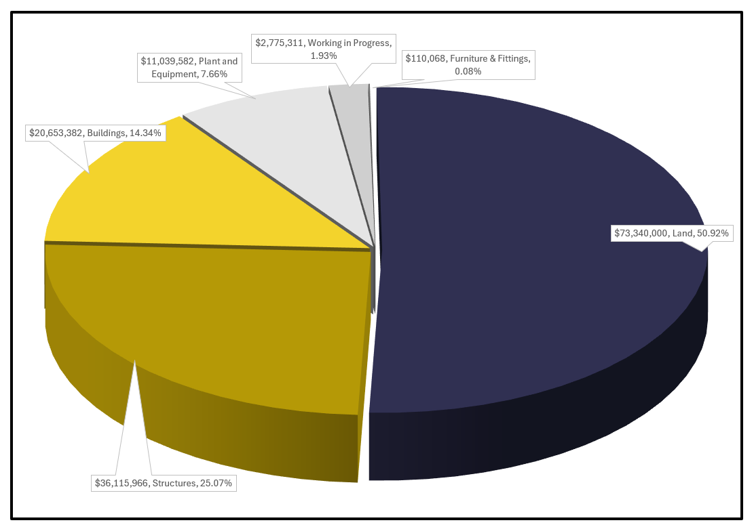
EMRC Asset Classes
The majority of EMRC’s assets are located in the following locations:
- The Red Hill Waste Management Facility, including the airspace;
- The Hazelmere Resource Recovery Park; and
- Ascot Place Office and neighbouring land.

The table below provides details of classes, sub-classes and the depreciation rate related to the assets managed by EMRC:
Asset Class | Asset Sub-Class | Useful life | Depreciation %
Building | - Council administration building  - Waste management facility building  - Other waste management building | 7.50 to 100 years  (Based on components) | 1.00% to 13.33%  (Based on components)
Infrastructure - General | - Siltation ponds  - Roads | 15 to 105 years  (Based on components) | 0.95% - 6.67%  (Based on components)
Infrastructure - Land Fill Cells | - Class III cells  - Class IV cells | Based on actual usage | % of actual use
Land | - Farm land  - Commercial land  - Council administration building land  - Waste management building land | Not applicable | Not depreciated
Plant | - Major plant  - Minor plant  - Red Hill landfill vehicles  - Ascot Place vehicles | 3 to 24 years | 4.17% to 33.33%
Equipment | - Office equipment  - Fire fighting equipment  - Security equipment  - Irrigation equipment  - Network communication equipment  - Telephone equipment  - Miscellaneous equipment | 3 to 25 years | 4.00% to 33.33%
Information Technology | - Hardware  - Software  - Systems (Records management, financial, human resources etc.) | 3 to 25 years | 4.00% to 33.33%
Furniture and Fittings | - Office furniture and fittings  - Miscellaneous furniture and fittings  - Artworks owned | 3 to 25 years  Artworks: Not applicable | 4.00% to 33.33%  Artworks: Not depreciated

Asset Management Strategy
EMRC’s revised 10 Year Strategic Plan focuses on sustainability and helps address social, environmental, economic and governance issues in an inclusive and effective manner. As the Western Australia’s transportation hub, the Region experiences rapid expansion and growth with major capital investments including intermodal freight terminal development, major airport and road development, and education and health investment.
These developments create a need for strategic and operational asset management planning to ensure that EMRC continues to deliver quality services to their six member councils.
EMRC’s asset management strategy is to plan, acquire and maintain an optimal asset portfolio to meet current and future delivery needs. The strategy involves maintaining capacity for existing service delivery needs and planning for new capacity to cope with future demands.
A clear strategy will ensure the following:
- Relevant legislative requirements together with political, social, economic and environmental requirements are considered;
- Consistent, systematic and appropriate asset management principles are applied across all levels;
- Integration of asset management with strategic planning and operational processes;
- Prioritisation of asset acquisitions, operations, maintenance and disposal activities;
- Sustainable assets are maintained by EMRC; and
- Key stakeholders are appropriately informed.

EMRC utilises an integrated asset management system to manage assets. The system assists EMRC in maintaining asset records, tracking costs, long term planning, modelling and revaluation.

6.1 Asset Acquisition

EMRC classifies asset acquisitions as acquisitions to replace existing assets or acquisitions to create new capacity.

Acquisitions to replace existing assets are intended to maintain EMRC’s current service delivery capacity whereas other acquisitions to create new capacity are aimed at enhancing service delivery capacity. Changing expectations for standards and capacity, technology advancement and new demands often contribute towards EMRC’s decisions to create new capacity.

All assets are acquired either through direct purchases or custom development. Direct purchases refer to purchases from open market or other agencies whereas custom development often involves capitalisation of costs associated with in-house or outsourced development of an asset.

All assets are acquired in accordance with EMRC’s Asset Management Policy.

Refer Appendix: 10 Year Capital Expenditure Programme (2026/2027 – 2035/2036).

(Ref: D2026/18048)

6.2 Operations and Maintenance
Individual business unit identify regular inspection and routine maintenance programs for major assets as part of operational asset management planning. These programs must be included in the approved OAMP and carried out by suitably qualified staff or contractor to ensure that they are in good working condition.
All staff must take due care when operating EMRC’s assets for official purposes. EMRC will ensure that all major assets are adequately insured against unfavourable events.
EMRC will conduct asset verification (i.e. asset count) on a date as determined by the Manager Financial Services to confirm the existence of assets included in the Asset Register.

6.3 Disposal and Destruction
Individual business units identify major asset disposal or destruction as part of operational asset management planning. All major asset disposal or destruction must be included in the OAMP.
EMRC currently has a 10-year replacement program for plant, equipment and motor vehicles based on number of years used, kilometres travelled or hours used. Assets with expired useful lives are replaced at the earliest opportunity to minimise maintenance costs.
All other minor obsolete assets are identified during annual asset verification process and disposed accordingly.

6.4 Post Life Cycle Analysis
EMRC undertakes post life cycle analysis for all major assets to evaluate usage patterns, actual useful lives, actual costs and benefits associated with the assets. The analysis is aimed at identifying improvement opportunities and additional requirements for acquisition or development of future assets.

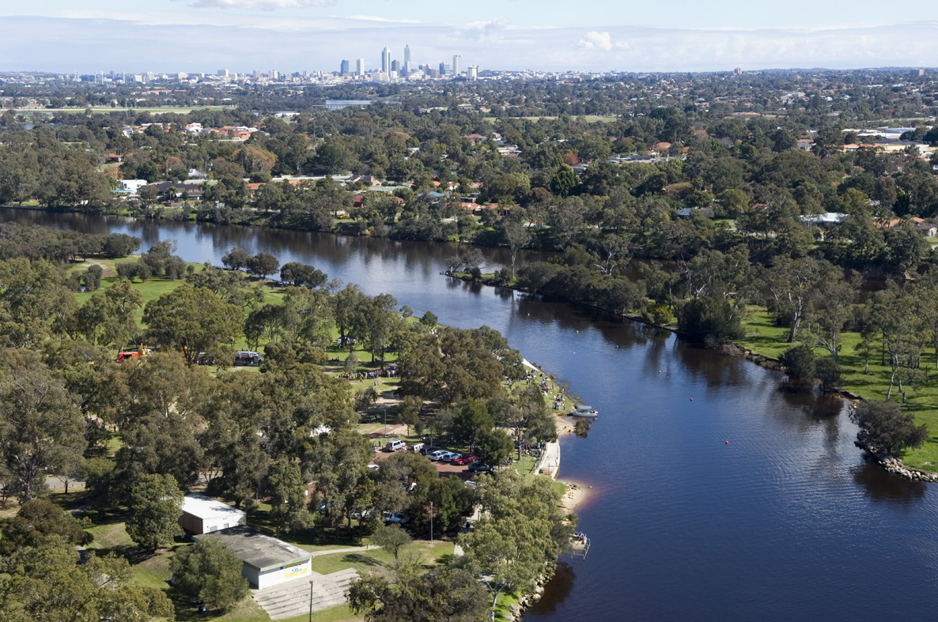

For further information please contact:

The Eastern Metropolitan Regional Council
226 Great Eastern Highway, Belmont WA 6104
Phone: 08 9424 2222

